STOP - THINK - CHOOSE

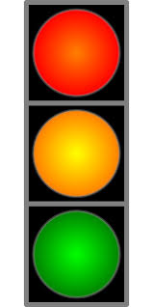
STOP – Take a breath, count to 5. Consider everyone’s feelings.

THINK – What is the problem? What are my choices? What are the consequences of those choices?

CHOOSE – Make a choice (consult with a helpful person for support!)

