WAVES OF PEACE MEDITATION

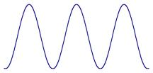

- Think of a happy/peaceful thought.
- Smile
- Breathe in – see the ball going up the hill - (breathe in what you want: ex, “I am perfect health.”
- Breathe out – see the ball going down the hill (breathe out what no longer serves you: “I now release all stress/illness etc from my life.”

(REPEAT FOR 2 MINUTES)

Add classical music:

Then use mudras below while singing:

SAT, TA, NA, MA – 1-2 MINUTES

